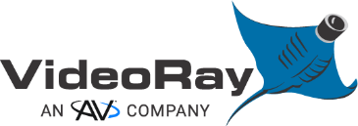
Command Maritime 2.1 UI
_OPERATOR MANUAL

For use with VideoRay Mission Specialist Pro 5, Ally, Defender & Wraith ROV Systems
VideoRay PN OM-78624
Version 2609117

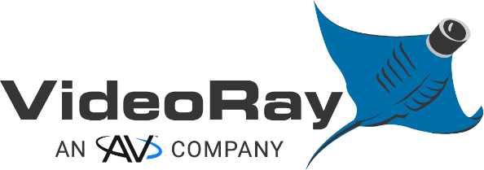
This material is copyright protected. No material may be reproduced or transmitted in any form or by any means for any purpose without expressed written consent of VideoRay LLC.
Copyright © 2026 VideoRay, an AV Company
_Table Of Contents
1. INTRODUCTION 5
2. SAFETY INFORMATION 6
2.1 General Safety 6
2.2 Electrical Safety 7
2.3 Operational Safety 7
2.4 Software & Control Safety 7
3. SYSTEM INTRODUCTION 8
3.1 Command Maritime UI 8
3.2 System Components 8
4. GETTING STARTED 9
4.1 System Inspection 9
4.2 Make Connections 9
4.3 System Power 10
4.4 Function Test 10
4.5 Launch ROV 10
5. USER INTERFACE OVERVIEW 12
5.1 Header Bar 13
5.1.1 System Menu 13
5.1.2 Record 18
5.1.3 Snapshot 18
5.1.4 Note 18
5.1.5 Auto Controls 19
5.1.6 ROV 3D Model 20
5.1.7 DVL Lock Indicator 20
5.1.8 Camera Angle 20
5.2 Control Menu Right 21
5.2.1 Map Control 21
5.2.2 Camera Controls 21
5.2.3 Sonar Controls 21
5.3 Main Display 22
5.3.1 Sensor Displays 22
5.3.2 Maps and Charts 22
5.3.3 Map Functions 22
5.4 Bottom Displays Left/Right 26
5.5 Command Menu 27
5.5.1 Maps 27
5.5.2 Navigation 27
5.5.3 Mission 27
5.5.4 Camera 28
5.5.5 Sonar 29
5.5.6 Power 30
5.5.7 Depth Profile 30
5.5.8 Diagnostics 30
5.6 Control Menu Left 31
5.6.1 Change Layout 31
5.6.2 Precision Movements 31
5.6.3 Enable/Disable Auto Controls 32
5.6.4 Expand/Collapse Arrow 32
6. NAVIGATION & MISSIONS 33
6.1 Navigation Overview 33
6.2 Navigation Sources 33
6.3 Missions Overview 34
6.3.1 Missions 34
6.3.2 Waypoints 34
6.3.3 Search Pattern 36
6.3.4 Mission Plan 37
6.3.5 Beginning a Mission 38
6.3.6 Point of Interest 39
7. SHUTDOWN PROCEDURE 40
8. CONTROLLER MAPPING REFERENCES 41
8.1 Expeditionary Splashproof Controller 42
8.2 VideoRay IP65 Industrial Hand Controller 43
8.3 Xbox Elite 2 Hand Controller 44
9. TOPSIDE CONSOLE REFERENCES 45
9.1 Workhorse Splashproof Controller Console 45
9.2 Workhorse Control Console 46
10. USING COMMAND MARITIME & GREENSEA 47
10.1 One-Time Installation 47
10.2 Configure the ROV for Greensea 48
11. VIDEORAY SUPPORT 49
11.1 Self-Service Support 49
11.2 Global Support 49
11.3 Regional Support 49
11.4 Training 49
11.5 Support Guidelines 50
11.5.1 Before Contacting Support 50
11.5.2 Customer Care Policy 50
11.5.3 Equipment Loaner 51
11.5.4 VideoRay Authorized Service Center 51
11.5.5 Warranty 51
11.5.6 Warranty Limitations / Exclusions 52
12. COPYRIGHT NOTICE 53

INTRODUCTION
This Operator Manual provides comprehensive guidance for the Command Maritime User Interface used with VideoRay Mission Specialist ROV systems. It is intended for trained operators and complements system-level operator Command Maritime User Guide and Quick Start field manuals.
For best results, thoroughly read and understand this manual and field manuals before Command Maritime operation. Contact VideoRay Support with questions regarding proper use of the software and care of the Mission Specialist ROV system.
Additionally, thoroughly read and understand the applicable Mission Specialist ROV Operator Manual and Quick Start field guides for the ROV configuration before use.

SAFETY INFORMATION

General Safety
Addressing all aspects of safety while working in a water environment is beyond the scope of this documentation. VideoRay encourages you to participate in safety training appropriate for your industry and applications, including such topics as vessel operations, first aid, survival, and other relevant topics.
Before setting up for or commencing any dive, it is always good practice to make sure there are no hazards to people or the equipment on land or in the water. If there are people in the water nearby, you should advise them that you are going to be operating the ROV. As the pilot/operator, it is your responsibility to ensure the safety of those around you as well as that of the equipment and nearby property.
Follow these recommendations whenever possible:
- Always complete pre-dive inspections before operation.
- Maintain situational awareness of tether, currents, and obstacles.
- Ensure proper ballast and buoyancy before deployment.
- Never operate the ROV beyond rated depth or environmental limits.
- Operating electrical devices in and near the water can be dangerous. There is always a risk of drowning or electrocution in such an environment. Reduce these risks by using common sense and observing safety regulations and recommended safe practice including the following:
  - Always test the safety components, such as ELCI switches and interlock devices, before beginning operations. Follow the procedures described in this manual for proper pre-dive inspection and system connections.
  - Have proper safety equipment, such as PFDs (Personal Flotation Devices), on hand and make sure you know how to use them before you need them.
  - Keep fingers, hair, loose clothing and other objects away from the ROV’s propellers and other pinch points.
  - Monitor weather and sea conditions and heed any warnings or alerts.
  - Be aware of and follow any legal ordinances or regulations in your area regarding operation of vessels and underwater equipment in the water.

Electrical Safety
- Never handle power cords while in contact with water or allow power cord connectors or the control panel to enter the water. The only components that can safely be placed in water are the submersible, any onboard accessories and tether, and only after making sure the connections are secure.
- Verify all power connections before energizing the system; use only approved power sources and connectors.
- Ensure power supply is sufficient for operation; when using a generator or inverter, a minimum of 3,000W continuous is recommended.
- Always connect the inline Equipment Leakage Circuit Interrupter (ELCI).
- Monitor the topside panel Line Insulation Monitor (LIM).
- Monitor and use appropriate system power level settings for the configuration.
- When using subsea battery power, monitor battery levels during operation.

Operational Safety
- Do not leave the ROV powered on in air for more than 15 minutes; overheating can cause shutdown and/or damage to components, specifically the ROV Power Module, sonar unit, and 4K camera.
- Keep personnel clear of propellers during deployment/recovery operations and maintain constant communication between the ROV pilot and other personnel.
- Be aware of both underwater and surface obstacles/hazards.
- When working from a vessel, ensure constant communication is maintained with the vessel operator.

Software & Control Safety
- Function test system components and controller prior to launch.
- Always verify control inputs before enabling thrusters.
- Disable auto controls and station keeping during recovery operations.
- Confirm correct navigation settings (e.g., magnetic declination).

SYSTEM INTRODUCTION

Command Maritime UI
Command Maritime is the primary control user interface for piloting, navigation, mission planning, and sensor management of all Mission Specialist ROV systems.
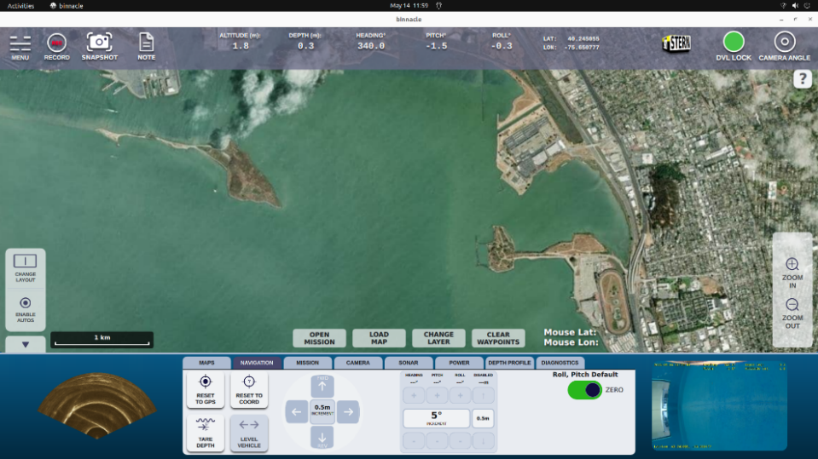

System Components
This Command Maritime Operator Manual includes instructions for operation with the following VideoRay systems and components:
- Mission Specialist Pro 5, Ally, Defender, and Wraith systems
- Workhorse Splashproof Controller and Workhorse Control Console topsides
- Expeditionary Splashproof Controller, IP65 Industrial Hand Controller, and Xbox Elite 2 controller (other Xbox controllers may be compatible; software configuration modification required)
- Mission Specialist Copper, Fiber Optic, and Hybrid Tethers
- Navigation Sensors (GPS, DVL)
- Integrated Sonar and Manipulators
- Mission Specialist Subsea Batteries

GETTING STARTED

System Inspection
It is always good practice to perform a pre-dive inspection before every dive. If any problems are noted, they should always be addressed before continuing.
- Ensure all system cases and components are present at the deployment site. Remove the float block and inspect all connections for proper mating and system components to make sure there are no visible signs of damage, loose, or worn parts. Check for moisture inside the camera dome.
- All subsea connections should have a small amount of silicone grease applied to the circumference of the connector sockets and mating surface prior to mating. Ensure all connectors are fully mated with no visible gaps.
- Check the thrusters to make sure the propellers are free to spin and are not significantly damaged, fouled with debris or fishing line, loose, or contacting the thruster nozzles. Check thruster telltales for indications of low oil reservoir levels. A telltale that has recessed into the thruster housing indicates that the thruster may be damaged internally.
- If equipped, check the manipulator and sonar units to ensure proper cable fitment and secure mounting.
- Replace the float block once the inspection is complete; extend the ROV GPS mast (if equipped).

Make Connections
Inspect tether and connectors for debris and condition. When not in use, keep the tether connectors protected with provided caps for the best reliability.
It is recommended to start at the ROV and work toward the power source:
- Align the tether pins and push the connectors together. Secure the locking collar by screwing the halves together.
- Connect the strain relief from the tether to the ROV with the retaining bolt and test all angles to prove no tension is on the tether connection.
- Connect the topside male end of the tether to the console’s 8-pin tether whip; for fiber optic tether or the Expeditionary Tether Reel connections, refer to the appropriate reference guide.
- With the Expeditionary Splashproof Controller, connect the Fischer cable to the HMI ports of the tablet and console.
- Connect the keyboard and controller to the console’s USB ports.
- Make any accessory connections (topside GPS, topside USBL beacon) within the console.
- Connect and plug the console’s power cord into a recommended and adequate power source.

System Power
- Power on control console and/or tablet
- Power on ROV (monitor air exposure time)
- Verify LIM reading is >4MΩ
- Launch Command Maritime software from the desktop
- Allow system initialization and sensor connection

Function Test
- Test thruster response for horizontal/vertical inputs
- Confirm LED lighting controls
- Check heading and orientation accuracy
- Validate sonar/manipulator (if installed)
- Check camera zoom, then tilt/pan controls

Launch ROV
- Launch the ROV into the water and ensure proper ballast/buoyancy for the specific system configuration; recommendations for typical operation has the ROV trimmed level (pitch/roll) and slight positive buoyancy at the surface. Adjust ballast weight quantities/locations as recommended for the most effective piloting.
- From the System Menu in the upper left corner of the interface, click/tap ‘System Manager’; select the ‘Navigation’ dropdown and enter the appropriate magnetic declination for the location of ROV deployment.
For ROVs with navigation (DVL/GPS) acquiring GPS satellite fix:
Locate the Navigation tab in the Command Menu at the bottom of the Main Display. Click on ‘Reset to GPS’ - the ‘LAT/LON’ position should now be displayed in the Header Bar.
In the Maps tab of the Command Menu, click on ‘Center Vehicle’ - the ROV position icon should now be centered in the Main Display.
- With the ROV icon viewable in the Main Display, select the preferred map or chart overlay with the ‘Change Layer’ or ‘Load Map’ buttons at the bottom of the Main Display; a wi-fi connection will be necessary for all maps not loaded onto the computer’s drive.
- Enabling auto controls aids in providing ROV stability and smooths out operator inputs. When autos are enabled, icons for Altitude or Depth, Heading, Pitch, Roll, and Positioning in the Header Bar will have a yellow bounding box and a setpoint displayed in yellow below the ROV’s current state.
There are two methods for enabling the auto controls:
  - Enable them in the Header Bar by:
Click/touch the icons for Altitude or Depth and Heading/Pitch/Roll group
Click/tap the ‘LAT/LON’ position coordinates to the right of the auto controls to enable station keeping with a DVL bottom lock
  - Use the ‘Enable Autos’ button in the Control Menu Left.
For ROVs with navigation, auto positioning/station keeping will also be enabled and functional with a DVL bottom lock
- Change the auto controls’ desired setpoint value with the Precision Movements controls from the Control Menu Left or with corresponding hand controller inputs. Note: Roll input is not programmed for VideoRay’s IP65 Industrial hand controller.

USER INTERFACE OVERVIEW
Below is an overview of the Command Maritime UI layout. For basic reference information in the field, refer to the Command Maritime Quick Start or User Guide.
Command Maritime UI layout consists of the following main components:
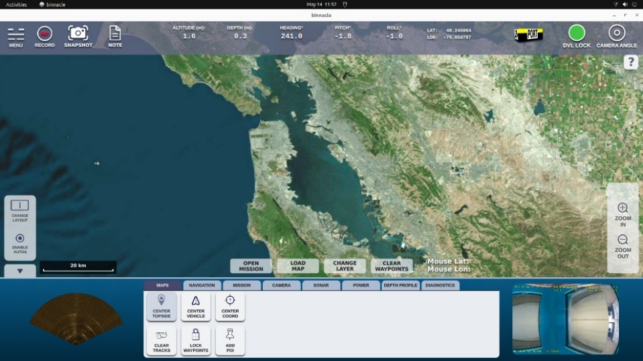
1
6
3
2
4
56
4

- Header Bar
- Control Menu Right
- Main Display
- Bottom Displays Left/Right
- Command Menu
- Control Menu Left

Header Bar
The Command Maritime Header Bar is an intuitive visual control center and provides values and controls including altitude or depth, heading/pitch/roll, and station keeping. The Header Bar is perpetually displayed so the following functions are always visible and include the following controls and sensor data:

- System Menu
- Record button
- Snapshot button
- Notes text entry
- Altitude/Depth
- Attitude (heading/pitch/roll)
- ROV GPS position
- ROV 3D model
- DVL lock indicator
- Camera tilt/pan indicator

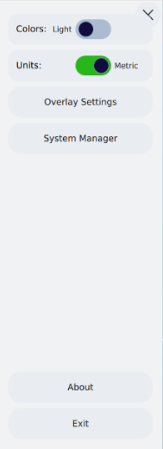
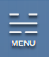
System Menu
In the left corner of the Header Bar is the System Menu, where numerous displays and control options are located.
- Colors: Light/Dark
- Units: Imperial/Metric
- Overlay Settings
- System Manager
- About
- Exit

Colors
Select either light or dark mode for the display, depending on lighting conditions and user preference.

Units
Select either imperial or metric units.

Overlay Settings
Select video imagery overlay content using the ‘Overlay Settings’ button; the operator can click/drag system and sensor information fields to the desired video feed window locations. The following fields are included:
- Date & Time
- Heading (compass)
- Pitch (in degrees, bow up is positive, down is negative)
- Roll (in degrees, to starboard is positive, port is negative)
- Depth (from surface)
- Altitude (from bottom with optional DVL)
- Floor (depth of current water column with optional DVL)
- Stream Name
- Manual Note (customized content typed in the ‘Note’ icon in the Header Bar)
The overlay text font color and size can be edited for user preference. Click/tap ‘Save’ once the desired overlay field is chosen, or ‘Reset’ to clear the overlay fields from the feed window.
Overlay preferences and display locations will be retained until modified.
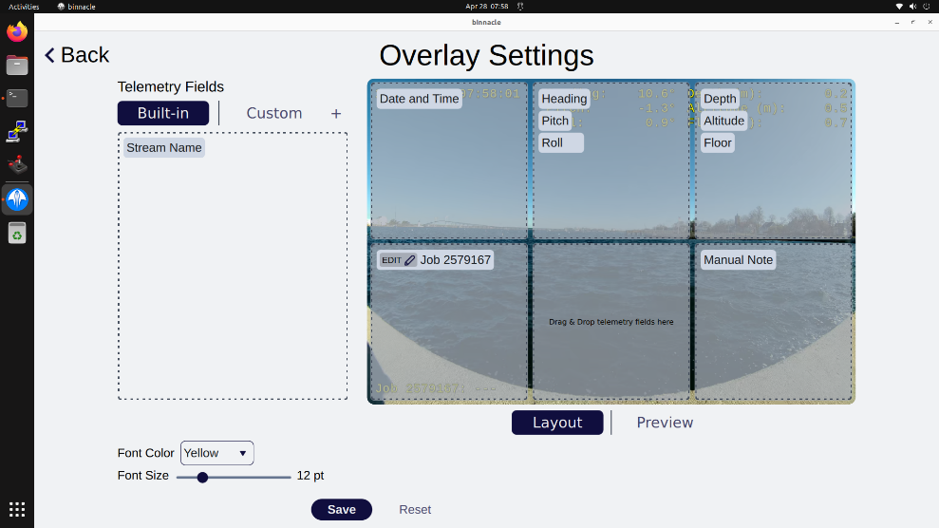

System Manager
The System Manager button opens a dropdown list of numerous diagnostic and settings tools:
- Process Summary: Displays the application state of system processes, e.g., AHRS, SONAR, Manipulator.
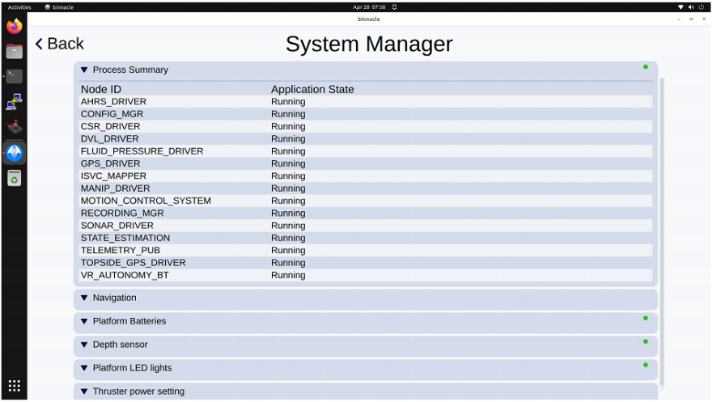
- Navigation: Allows for the entry of magnetic declination for the location. Note: Magnetic Declination values are not retained after a power cycle.
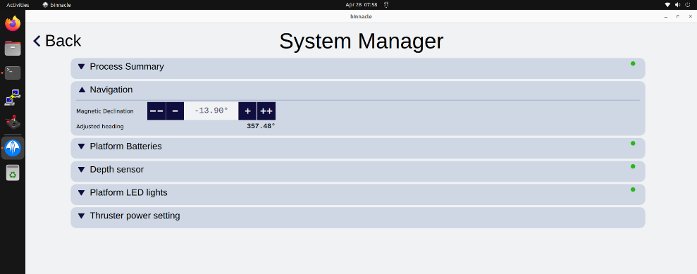

- Platform Batteries: Displays each subsea ROV battery’s real-time health and voltage statistics.
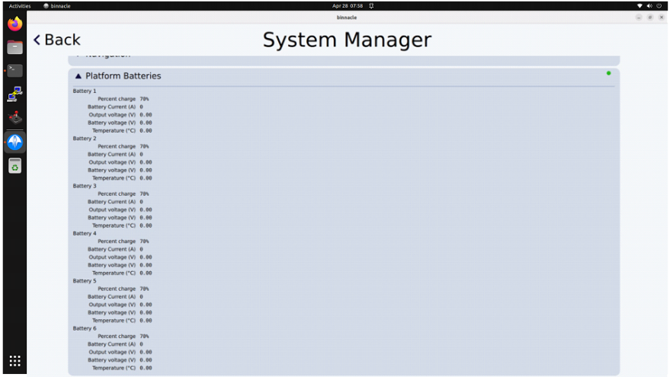
- Depth Sensor: Displays real-time AHRS information and allows for Zero depth reset. A reset will communicate a ‘surface/zero depth’ pressure to the depth sensor, therefore reset only when at or near the surface. If the reset is inadvertently applied at depth, return the ROV to the surface and perform another reset. Note: Auto depth control must be disabled prior to reset.
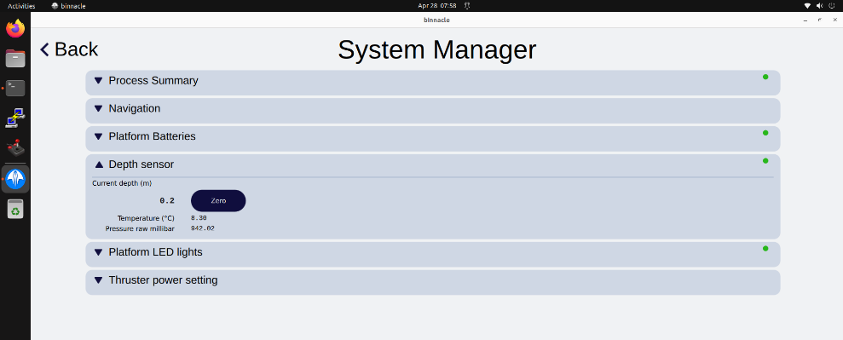

- Platform LED: Displays real-time LED status information and allows for wide/narrow beam adjustments.
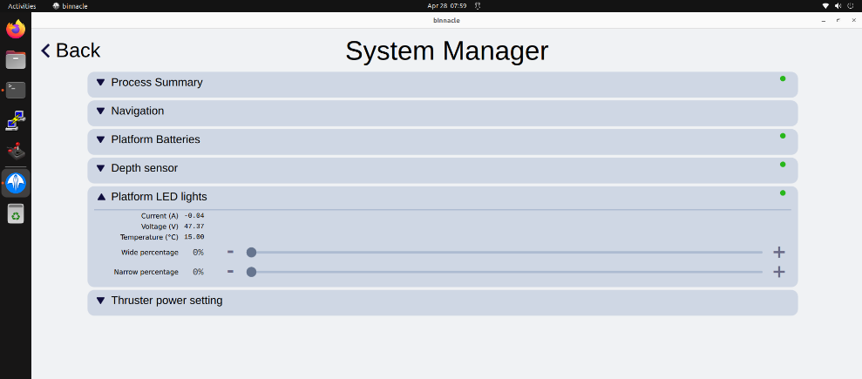
- Thruster Power Setting: Allows for power limit (Watts) and input sensitivity adjustments. The recommended power limit for Defender, Ally, and Pro 5 ROVs is 1,000 Watts with a maximum of 1,500 Watts. The maximum power limit for configurations using topside power will be dependent on total tether length and sufficiency of topside power.
The recommended power limit for Wraith ROV with a subsea six-battery Expeditionary configuration is 6,000 Watts.
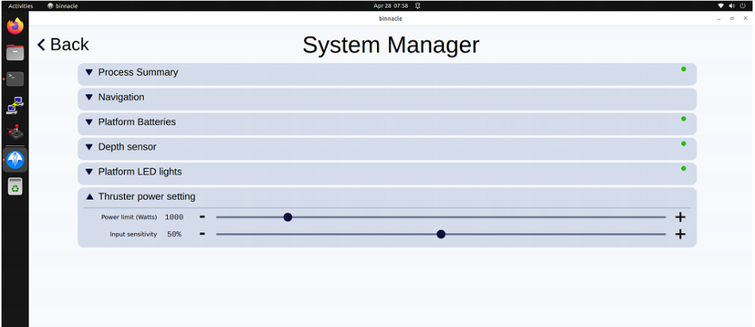

‘About’ Button
Click/tap the ‘About’ button to see current software version and details.

‘Exit’ Button
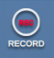
Click/tap the ‘Exit’ button to close the Command Maritime UI. The ‘x’ in the right corner of the main window may also be used to exit the software.

Record
The Record button - or corresponding controller input - starts/stops recording. Video files increment to a new part every 15 minutes and sonar files increment to a new part every 500MB, and are saved in the ‘/home/videoray/videoray-recordingsʼ folder with a subdirectory having the current date. Filenames include the date and time when the recording started. Recording does not begin automatically upon launching the ROV and requires a manual start.
Recording using the Header Bar button or controller input captures the following:
- Video stream of the UI display – mp4
- All camera feeds (with overlays) – mp4
- Sonar feed – native (OEM) file type, played back via OEM software
Only the monitor displaying the Command Maritime UI will be captured using the Record function. If external monitors are connected and displaying extended sensor windows, options for recording external monitors are as follows:
- 4K Camera feed: Record locally using the camera’s web UI
- Sonar feed: Use the OEM software for viewing/recording sonar data (see the Sonar section for further information)

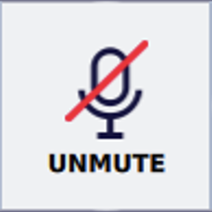
If a microphone button is shown in the header bar, the option to record audio with video is available. Click/tap the button to mute/unmute audio while recording. The button icon displays the current audio setting.

Snapshot

The Snapshot button – or corresponding controller input - captures and saves two files: a screenshot of the current UI display, and a high-resolution camera image with no overlay content. Image files are named by date/time captured and are saved in the ‘/home/videoray/videoray-recordings’ folder with a subdirectory with the current date.

Note
Clicking/tapping the Note button opens a window to type custom text, which will be shown in the ‘Manual Note’ overlay field. Enter project or target-specific notes and capture snapshots with the text displayed. Re-open the Note window to modify the text for subsequent snapshots or delete the text to clear it from the overlay field.

Auto Controls
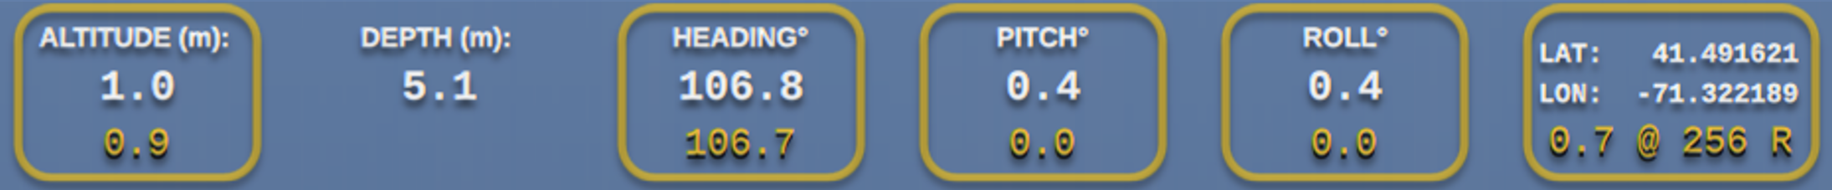
The Command Maritime UI software enables the operator to hold the ROV’s depth or altitude, heading, pitch, roll, and lat/lon position via auto controls. When enabled, a ‘setpoint’ for the specific auto control is established and maintained for as long as operational conditions allow, or until it is adjusted or disabled by the operator. Auto controls for altitude, depth, heading, pitch, roll, and station keeping each have their own icon as shown above. The operator can toggle auto controls by clicking/tapping the icons, with Heading, Pitch, and Roll enabled/disabled as a group. To enable or disable all available auto controls simultaneously, click/tap the ‘Enable/Disable Autos’ button in the Control Menu Left.
The number of thrusters on the ROV generally dictates the ability of an auto control to hold pitch and roll attitudes. These attitudes, along with surge (forward/reverse), heave (surface/dive), yaw (rotate L/R), and sway (lateral L/R), comprise the ROV’s ‘degrees of freedom’ (DOF). Mission Specialist Defender and Wraith ROVs are equipped with seven and ten thrusters respectively, offering a true 6 DOF while both static and flying. Mission Specialist Pro 5 is equipped with three thrusters and Ally with four; therefore, they offer 3 DOF (surge, heave, yaw) and 4 DOF (surge, heave, yaw, sway) respectively. Further information on Pro 5 and Ally systems can be found at the end of this section.

Altitude and Depth
Icons for Altitude (via optional DVL and bottom lock) and Depth (via ROV AHRS pressure sensor) display the ROV’s position in the water column. When either auto control is enabled, the icon will be highlighted with a yellow bounding box and the setpoint will be displayed in yellow text at the bottom of the icon. For vertical auto controls (altitude/depth), only one can be enabled at a time; enabling one will disable the other. Adjust the setpoint with the corresponding controller function or using Precision Movements controls from the Control Menu Left.

Heading, Pitch, and Roll
Auto controls for Heading, Pitch, and Roll display the ROV’s current heading/attitude and are enabled/disabled as a group. When these auto controls are enabled, they will each be highlighted with a yellow bounding box and the setpoint will be displayed in yellow text at the bottom of the icon. Adjust the setpoints with the corresponding controller function or using Precision Movements controls from the Control Menu Left.
Pitch and Roll setpoints will revert/hold at 0˚ when enabled by default. To hold pitch and roll angles at their current attitude, the operator may toggle the selector in the Navigation Tab, which will use and hold the ROV’s current roll and pitch angles.

Station Keeping
The Auto control for Station displays lat/lon position and the distance/bearing to a selected map item. The ROV’s position on the surface is typically acquired via GPS satellite fix and is maintained beneath the surface with a DVL bottom lock. An optional integrated USBL system may enhance/correct underwater positioning when depth or sea floor conditions hinder or prevent DVL accuracy.

Pro 5 and Ally Systems
Because Mission Specialist Pro 5 and Ally systems have less DOF capability, auto controls are limited but all available controls retain the same functionality and operability. The figures below illustrate the visible differences for each ROV, with neither having pitch/roll controls and Pro 5 lacking positioning. Note: Ally equipped with optional DVL enables autos for altitude and positioning with bottom lock.
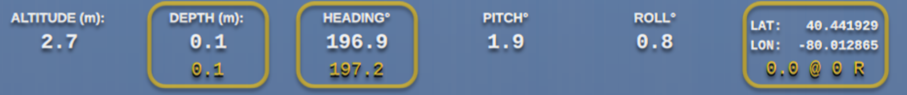
Mission Specialist Ally (with DVL)
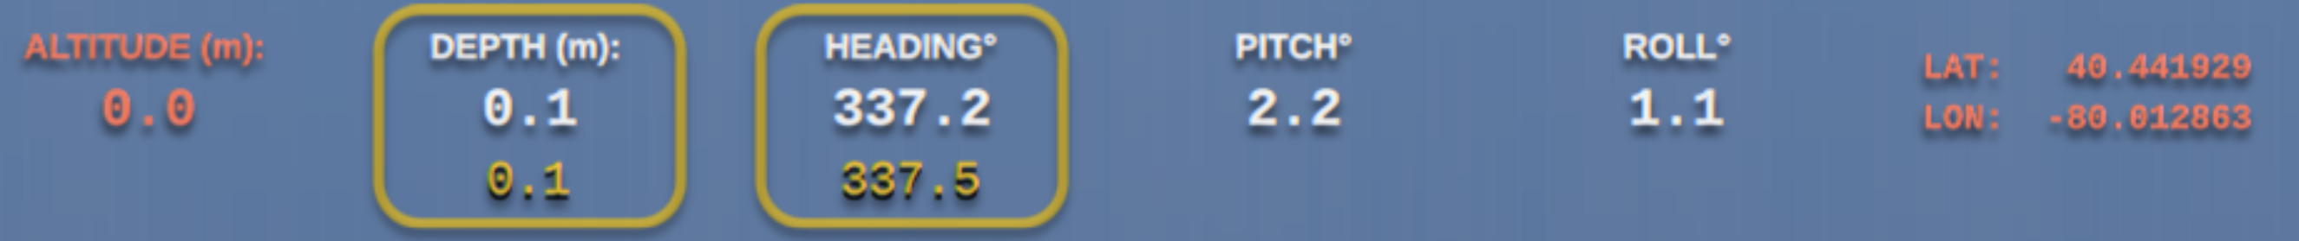
Mission Specialist Pro 5


ROV 3D Model
The ROV 3D perspective model is intended to provide the operator with a quick visual reference of the ROV state, including heading, pitch, and roll. The viewpoint of the model is oriented from a position behind the ROV relative to due north.

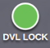
DVL Lock Indicator
The DVL indicator displays green for a valid bottom lock and red with no lock.

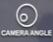
Camera Angle
The ROV camera’s current tilt and pan is displayed with a field of view (FOV) graphic indicator, with the outside circle representing maximum tilt/pan extents, and the inner circle representing the current view’s tilt/pan position. The zoom level is not indicated within the graphic indicator.
Tilt/pan functions are managed in the Control Menu Right or with corresponding controller inputs. The pan function is only enabled when the camera zoom is utilized; otherwise, the extents of the camera’s horizontal FOV are already displayed and no pan is necessary for full horizontal view.

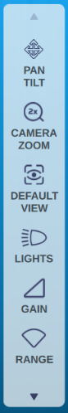
Control Menu Right
The Control Menu Right is a dynamic menu with controls that are specific to the active sensors in the Main Display. Each sensor - map, sonar, and camera - has a unique set of controls that allows the operator to adjust its performance and display.
When dual displays are selected (see Control Menu Left), the menu will combine controls for both sensors. Arrows at the top and bottom of the menu will indicate additional controls not visible, as shown in the example to the right.
A click/tap for each icon in the menu opens a flyout submenu to control that function. The following sensor controls are displayed for each sensor:

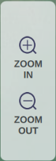
Map Control
The map control menu is simplified with zoom in/out functions:


Camera Controls
The camera control menu offers common functions for quick access:
- 4K Camera: Pan/Tilt – must enable zoom for pan
HD Camera: Zoom/Tilt
- Camera Zoom – from 1x-3x
- Default View – centers pan/tilt, resets to 1x zoom
- Lights – adjust wide/narrow beam


Sonar Controls
The sonar control menu includes the following functions and includes a high/low frequency control:
- Gain – 0-100%
- Range – FLS model-specific
- Frequency – High/Low model-specific
- Colors – Grayscale, Bone, Heat
- Start/Stop – Starts/stops transmission

Main Display

Sensor Displays
The Main Display allows the operator to toggle between sensor feeds and offers multiple configurations using the Control Menu Left, providing real-time feeds of the map, sonar, and/or camera imagery. Sensor-specific menus appear in the Control Menu Right for direct access.
Selecting the preferred imagery via click/tap from either the left or right Bottom Display (map, sonar, or camera) will swap it with the Main Display. This allows the ROV operator to maintain a live display of all sensors while providing a larger view of the preferred sensor feed.
If the ROV is equipped with an auxiliary integrated camera, both camera imagery feeds can share the Main Display in a primary/secondary view layout. Toggle camera views by clicking/tapping on the secondary view, which swaps it to the primary view. The Command Menu must be displayed to toggle views.

Maps and Charts
If not already displayed, select the map as the primary view in the Main Display. Georeferenced maps and charts not already loaded onto the computer’s drive will require a Wi-Fi connection. Note: To connect to Wi-Fi, click the settings icon in the upper right corner of the desktop, ensure Wi-Fi is on, and select the Wi-Fi source.

Map Functions
The Main Display includes numerous buttons and features when the map is the primary display.
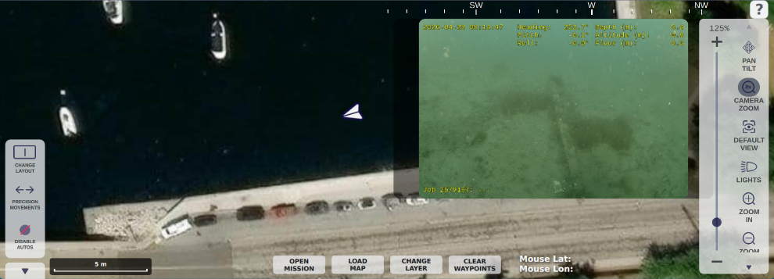
7
1
6
5
4
3
2

- Graphic Scale
- Open Mission Button
- Load Map Button
- Change Layer Button
- Clear Waypoints Button
- Mouse Position
- Help Menu

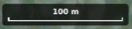
Graphic Scale
The Graphic Scale is a visual indicator of the map’s current scale and zoom level. It is especially useful for open water deployments with no visible shoreline in the map. Note: The Graphic Scale is currently displayed in metric units, regardless of imperial/metric selection.

Open Mission Button
Clicking/tapping the Open Mission button will launch the ‘Mission Plan’ fly out menu in the left edge of the Main Display. Information about waypoints added to a mission will be displayed, where the operator can reorder waypoints and use mission controls – see Mission Operation section for further details.

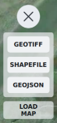
Load Map Button
The Load Map button provides a menu selection of compatible map files: GeoJSON, Shapefile, and GeoTIFF.
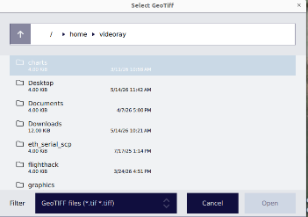
Once the desired file type is selected, a file browser window will launch filtered by the selected file type. Locate and open the map file from the directory.

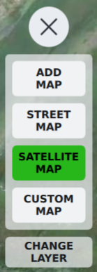
Change Layer Button
The Change Layer button provides a selection of map layers and allows for adding additional maps.
The default map layer options are shown below:
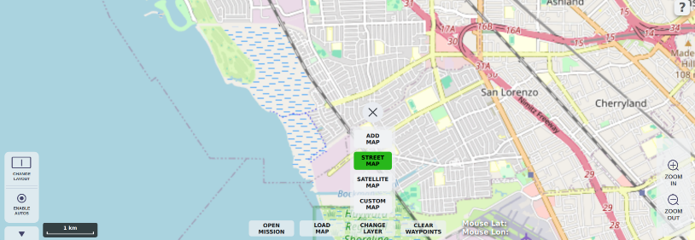
Street Map
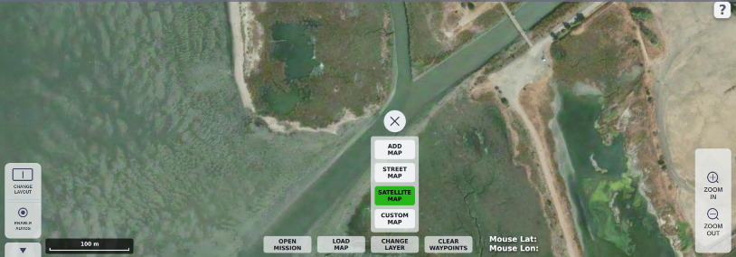
Satellite Map
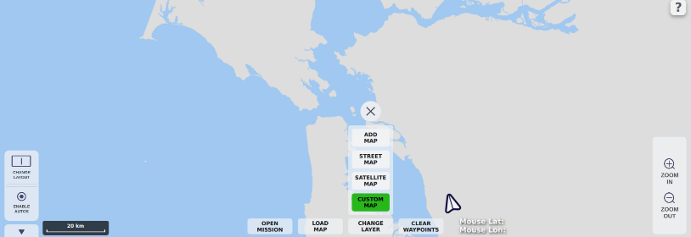
Custom Map
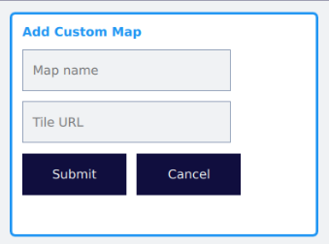
When ‘Add Map’ is selected, a window for naming and entering a URL appears in the display. Click/tap ‘Submit’ after entering these fields.

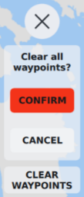
Clear Waypoints button
The Clear Waypoints button will remove all waypoints from the map. A confirmation prompt will appear to help avoid accidental removal; click/tap ’Confirm’ or ’Cancel’.

Mouse Position
The Mouse Position text displays the GPS lat/lon position of the cursor in real time.

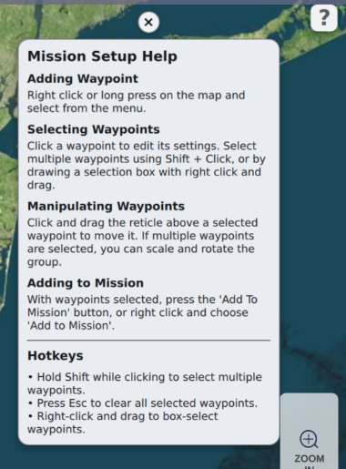
Help Menu
Clicking the Help Menu icon opens a menu that aids the operator with Mission Setup:
- Adding Waypoint
- Selecting Waypoints
- Manipulating Waypoints
- Adding to Mission
- Hotkeys
Click/tap the ‘X’ above the menu to exit.

Bottom Displays Left/Right
The Bottom Displays – Left and Right - provide secondary sensor views and allow the operator to monitor and move sensors not displayed in the Main Display.
The sensors viewed in these displays can still be controlled and their feed displays adjusted in their respective menus in the Command Menu tabs.
To move a sensor from either Bottom Display, click/tap to swap it with the sensor in the Main Display.

Command Menu
The Command Menu provides the operator with various system and display controls and can be collapsed with the arrow under the Control Menu Left for maximum display area. The Command Menu contains the following tabs:

Maps
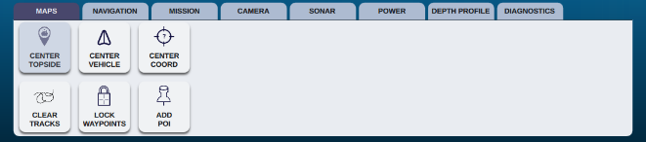
The Maps tab menu provides controls for centering the ROV or topside GPS position in the map. The operator can also center the map to coordinates entered manually.
Clearing breadcrumb track history, locking existing waypoints, and adding points of interest (POI) are also available controls in the Maps tab.

Navigation
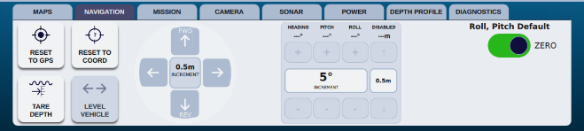
The Navigation tab menu allows the operator to reset the ROV’s position to GPS when on the surface with a valid GPS fix, or reset to coordinates entered manually.
With the depth or altitude auto control disabled, click/tap the ‘Tare Depth’ button to zero depth when the ROV is at the surface and idle.
Precision Movements controls for heading, pitch, roll, and depth are shown here and in the Control Menu Left. When auto station keeping is enabled with DVL bottom lock, horizontal controls for forward, lateral, and reverse are also accessible.

Mission
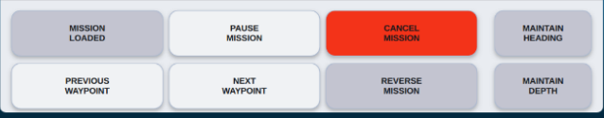
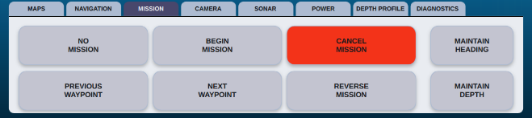
The Mission tab menu is the control center for active missions. When a mission is loaded, the operator can begin, pause, resume, cancel, and reverse a mission, or go to the previous or next waypoint in the mission path.
While a mission is paused, the operator can manually adjust the ROV’s heading and depth with controller inputs. Enabling ‘Maintain Heading’ and/or ‘Maintain Depth’ by clicking/tapping will maintain their current states and override the respective mission waypoint heading and/or depth defaults upon continuing a mission.

Camera
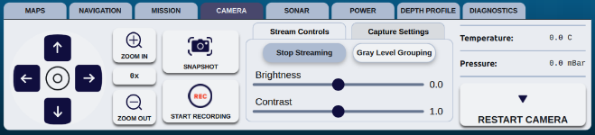
The Camera tab menu features an array of Ultra 4k Smart Camera functions, including controls for tilt/pan/zoom, snapshot/record, stream, brightness, contrast, capture, and camera diagnostics. Note: 4K camera menus shown; functionality and camera resolution options will vary when operating with an HD camera.
The ‘Snapshot’ button captures both a screenshot of the display and a high-resolution camera feed image without overlay content. The resolution of the image is displayed in the ‘Capture Settings’ subtab.
The ‘Start/Stop Record’ button captures video recording from the camera for greater resolution and is not the same as the UI recording captured using the ‘Record’ button in the Header Bar or via controller input. The resolution of the recording is selected and displayed in the ‘Capture Settings’ subtab.
The ‘Stream Controls’ subtab allows the operator to modify the live stream of the camera, including brightness and contrast. The operator can also toggle the camera stream on and off using the ‘Start/Stop Streaming’ button. This allows for omitting the video feed through the tether to minimize bandwidth, typically advantageous when integrating additional high-bandwidth sensors.
Gray Level Grouping (GLG) is an image enhancement algorithm that aids in highlighting objects and areas that may be difficult to identify.
The operator can also modify brightness and contrast values to digitally enhance the video feed. For instance, the brightness and contrast values can be increased if in a dark area to enhance a faint object. Note that the default value for brightness is 0.0 and contrast is 1.0.
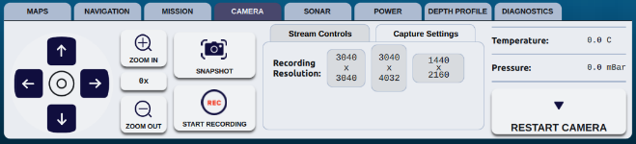
The ‘Capture Settings’ subtab allows the operator to change the recording resolution affecting the size and aspect ratio of snapshots and recordings captured from the Camera tab menu.
Camera temperature and pressure levels are also displayed, as well as a button to restart the camera without needing to cycle power to the vehicle.

Sonar
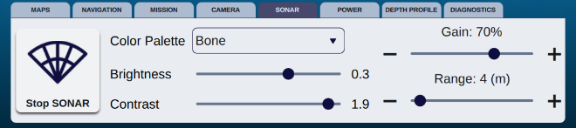
The Sonar tab menu has display controls for Color Palette, Brightness, and Contrast, as well as sensor controls for Gain and Range. The display settings can be adjusted for the preference of the operator and/or sonar viewing personnel.
Gain settings should generally increase and decrease with more and less transmission range, respectively. Range settings are specific to the integrated sonar sensor in use on the vehicle; for dual frequency units, high frequency (for identification and improved clarity) will result in a shorter range capability, while low frequency (for navigation) will allow for a longer range. Use the Control Menu Right when the sonar feed is in the Main Display for Frequency controls.
Sonar transmission can be ceased via click/tap of the ‘Stop SONAR’ button. This control is used when sonar transmission is not desired for an operation, or when electing to view sonar imagery through its OEM software.

Using OEM Sonar Software
Ensure sonar transmission is stopped before launching OEM software.
- Launch the OEM software (must be Linux-compatible) in the VideoRay console computer or tablet, then choose from the following options:
  - Hold the Windows button and press either the left or right arrow key to enable split screen viewing, allowing for the UI and OEM software to be viewed side-by-side on the VideoRay computer or tablet monitor, or
  - Connect an external monitor via HMDI cable, extend the display in the desktop display settings, and move the OEM software window to the external monitor, or
  - Connect an external PC with OEM software to the VideoRay console or tablet via CAT 5e ethernet cable
- Start/ping the sonar using the OEM software controls.
To resume sonar feed to the Command Maritime UI, the OEM software must first be closed and fully exited. Next, click/tap the Command Maritime 'Start SONAR' button; the sonar feed should appear in the display. Note: Some user preference settings made in the OEM software may be retained.
Enabling ‘Record’ while viewing in the Command Maritime UI will save a native (OEM) sonar file; recording while viewing in OEM software will not save sonar data. If sonar recording is desired during this time, use the OEM software’s record feature.

Power
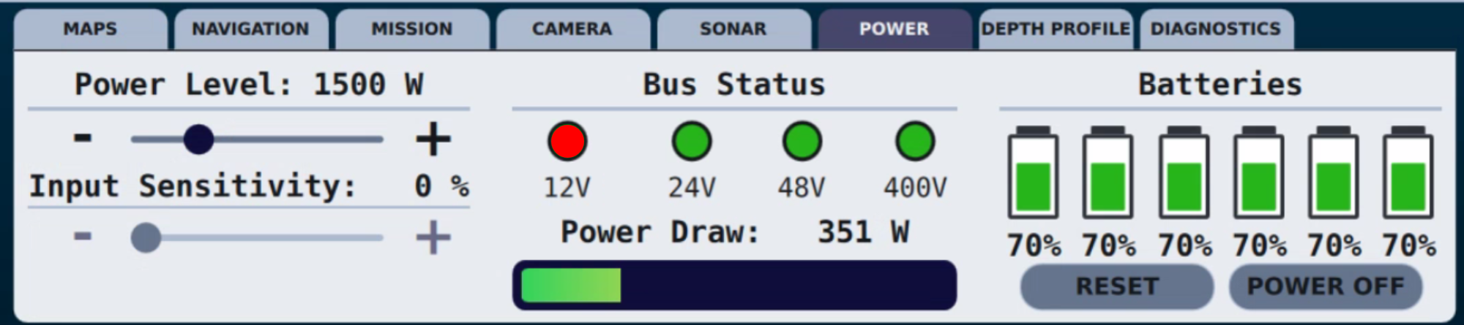
The Power tab menu allows the operator to adjust the maximum commanded thruster power. Input sensitivity ranges from 0-100% and adjusts controller input levels for operator preference.
Power Draw, Bus Status, and ROV subsea battery state of charge (SOC) levels are displayed for monitoring.
Bus 12V status displays red for this version; however performance/component power are not affected.
Subsea battery ‘Reset’ and ‘Power Off’ buttons are displayed but are non-functional for the current software version.

Depth Profile
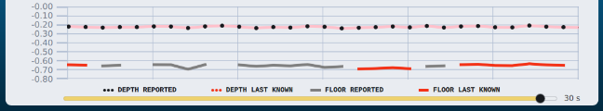
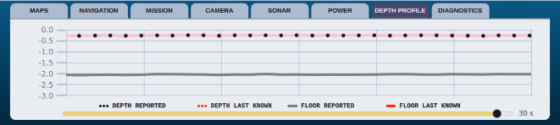
The Depth Profile tab menu displays depth/floor history as a visual reference to the operator. A legend for the graph and a history slider - from ten seconds to ten minutes - are at the bottom of the menu.

Diagnostics
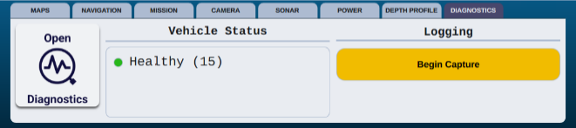
The Diagnostics tab menu has a button to open the diagnostics ‘Process Summary’ and displays ROV software application status.
The ‘Begin Capture’ button initiates logging of system telemetry used for technical support. Logging of telemetry should not typically be enabled unless system issues arise and is necessary to aid in diagnosing a software or system fault.
Contact VideoRay Support for information on capturing telemetry.

Control Menu Left
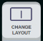
The Control Menu Left has controls for changing the layout, using precision movements, and enabling/disabling the auto controls.

Change Layout
When the operator clicks/taps the Change Layout button, a menu allowing different display options appears above, including Single, Dual, 3D, and Window (opens the feeds in separate windows, which enables any feed to be moved to an extended monitor if desired). Choose the layout that best suits the operation and operator preference.
When using dual display, the views - map, sonar, and camera - can be toggled through until the desired display is achieved. If the ROV is equipped with an auxiliary integrated camera, both camera imagery feeds can share the Main Display in a primary/secondary view layout. Toggle views by clicking/tapping on the secondary view, which swaps it to the primary view. The Command Menu must be displayed to toggle views.
The following keyboard shortcuts are enabled to change the display layout:
- F1: Single display
- F2: Dual display
- F3: 3D display
- F4: Window

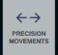
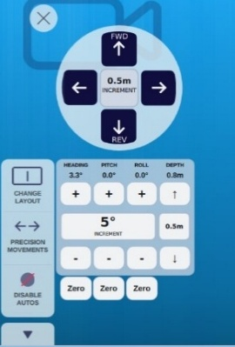
Precision Movements
The Precision Movements controls provide for operator-specified distance/degrees input and navigation, typically utilized for small, incremental movements during inspection or object recovery operations.
When Auto Controls are enabled, the Precision Movements controls button is displayed in the Control Menu Left; the controls are also visible in the Navigation tab of the Command Menu.
Click/tap the button to open the controls window to the right, which allows for distance and degree input values for precision movements in heading, depth, pitch, and roll. Each click/tap on the + or - buttons moves the ROV in the specified distance or degrees. To change the specified values of distance or degrees, click/tap on the icon displaying the input value, which will open an editable menu.

The auto control setpoints for heading, pitch, roll, and depth are displayed above the ‘+’ buttons for quick reference and will indicate a change of distance or degree value with each +/- input. DVL bottom lock is necessary to enable Precision Movements for all six degrees of freedom, adding surge (forward/reverse) and sway (lateral). Note: When applying very small incremental inputs, ROV response and movement may not be apparent to the pilot in sensor feeds, so it is recommended to monitor and confirm the setpoint adjustments with each +/- input.
Close the Precision Movements controls with the ‘X’ in the upper left of the window.

Pro 5 and Ally Systems
Mission Specialist Pro 5’s three thruster configuration allows for 3 degrees of freedom (DOF) – surge, heave, yaw – and is not offered with an integrated DVL. As a result, it offers limited Precision Movements controls via the AHRS module for depth and yaw only.
Mission Specialist Ally is equipped with a four thruster configuration with 4 DOF – surge, heave, yaw, sway – and is optionally equipped with an integrated DVL. This configuration enables the addition of horizontal controls for surge (forward/reverse) and sway (lateral) with a DVL bottom lock.

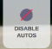
Enable/Disable Auto Controls
At the bottom of the Control Menu Left is the ‘Enable’ or ‘Disable Autos’ button. When the operator clicks/taps the button, all available auto controls are either enabled or disabled and will be indicated in the Header Bar. This feature is beneficial to an operator when quick access to enable auto controls are desired or to disable them during ROV recovery.
Auto controls for heading/pitch/roll are linked and will be enabled/disabled as a group. Auto depth will be enabled by default.
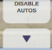
With DVL bottom lock, station keeping will also be enabled/disabled with the group. When enabled, the pilot has the option to switch to an altitude lock in lieu of depth.

Expand/Collapse Arrow
Below the Control Menu Left is the expand/collapse arrow for the Command Menu, which toggles the menu out of view, allowing for maximum display area when desired. The arrow will remain in view at the bottom of the Main Display to expand the menu when needed.

NAVIGATION & MISSIONS

Navigation Overview
When equipped with navigation (GPS/DVL), it is critical to ensure accurate ROV positioning whenever creating mission waypoints or Points of Interest (POIs). Inaccurate positioning will result in errors with mission planning and navigation. Ensure to enter magnetic declination in the ‘Navigation’ dropdown menu of the System Manager before operations.
Upon startup, the ROV’s position will have a LAT/LON position of 40.44193008512556, -80.01286385010803. As outlined in the Launch ROV section, correct the ROV’s position with a valid ROV GPS fix via a click/tap of the ‘Reset to GPS’ button in the Navigation tab of the Command Menu. If the ROV cannot acquire a valid GPS fix or is not equipped with a GPS mast, click/tap the ‘Reset to Coord’ button in the Navigation tab. A text entry field will open and allow for a position to be entered manually.
Next, click/tap the ‘Center Vehicle’ button in the Maps tab of the Command Menu. The ROV beacon should now be displayed in the center of the Main Display and accurately referenced in the selected map.

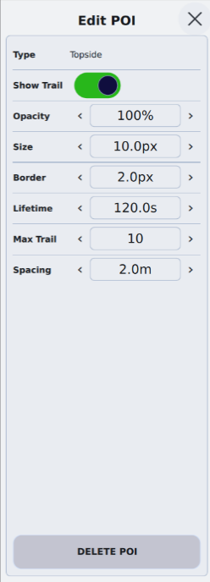
Navigation Sources
Navigation sources in the map view displaying GPS positioning include the topside controller GPS puck, the ROV GPS receiver, and the Doppler Velocity Log (DVL). These sources are selectable as POIs, where the operator can edit visible characteristics of each type when selected, as shown to the right:

  - Show/hide trail
  - Opacity
  - Size
  - Border
  - Lifetime (trail in seconds)
  - Max Trail (length)
  - Spacing (trail dots)

Navigation source POI icons are displayed as follows:

ROV GPS
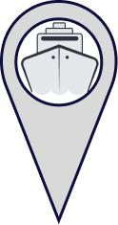
DVL (ROV state estimate)
Topside GPS position
When on the surface with a valid GPS fix and DVL bottom lock, the ROV GPS and DVL will both display navigation source positions. If during underwater navigation the ROV had accumulated positioning error with the DVL, the variance will be visible in the map upon surfacing. The variance can be corrected with the ‘Reset to GPS’ button in the Navigation tab of the Command Menu.

Missions Overview

Missions
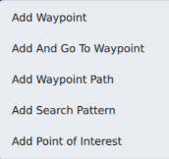
A mouse or integrated keyboard ball/pad is recommended to perform most mission functions; otherwise for left-click functions, tap the screen; for right-click functions, long-press the screen.
The Main Display in map view is the primary workspace for missions. Right-clicking in the map display opens a context menu where waypoints, waypoint paths, search patterns, and points of interest (POI) can be added, as shown to the right.

Waypoints
When ‘Add Waypoint’ is selected from the context menu, it will be visible in the Main Display at the cursor’s right-click position.
When ‘Add and Go to Waypoint’ is selected from the context menu, it will be visible in the Main Display at the cursor’s right-click position. The ROV will respond and begin the mission using system default waypoint parameters.
When ‘Add Waypoint Path’ is selected from the context menu, a modified cursor will appear. Each subsequent left click in the Main Display will create a new waypoint to form a path. To end the path, right-click anywhere in the map.

Selecting Waypoints
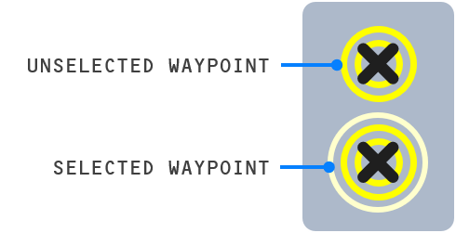
When waypoints are selected, they are highlighted with an outer ring. Select waypoints using the following methods:
- Left-click in the center of a single waypoint.
- Hold Shift + click/tap while selecting waypoints, or right-click to drag a box surrounding two or more waypoints in a group.
Once selected, the ‘Edit Waypoint’ menu will fly out in the left edge of the Main Display, which defines current parameter values of the selected waypoints. These values command the state of the ROV at the time it reaches a waypoint.

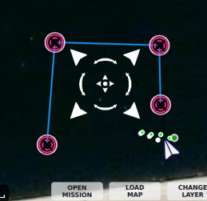
Moving Waypoints
A single selected waypoint can be moved individually by left-clicking/tapping and dragging.
A group of selected waypoints can be moved, resized, or rotated by left-clicking/dragging the reticle arrows inward, outward, and around the group, as shown to the right.

Editing Waypoints
To view/edit waypoint parameters, select a single waypoint or set of waypoints.
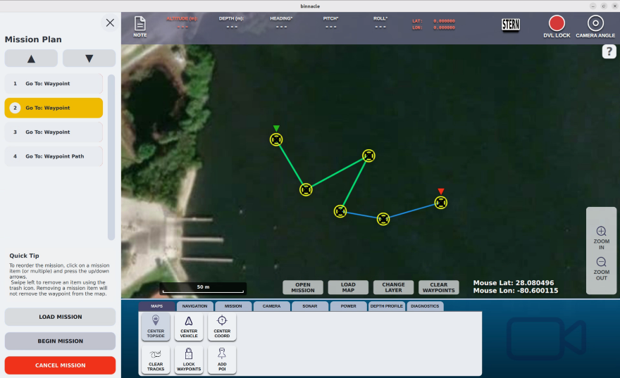
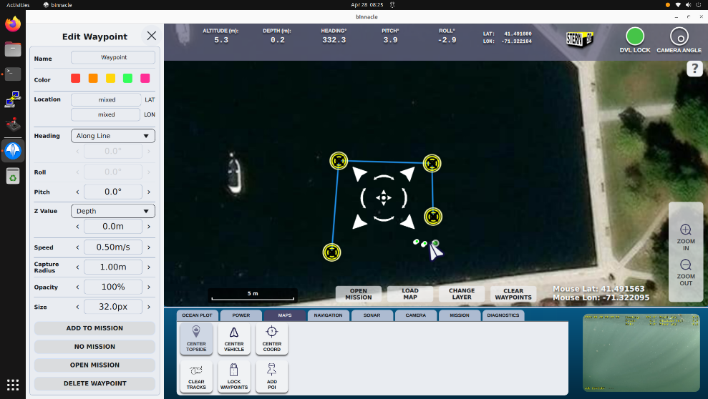
The following characteristics of selected waypoints can be edited in the menu:
- Name & Color
- Heading
- Along Line – direct navigation to waypoint (current, precise patterns)
- Fixed – set compass heading during navigation
- Roll (ROV +/-, with Fixed heading only)
- Pitch (ROV +/-)
- Z Value
  - Depth
  - Altitude

- Speed (ROV maximum to waypoint)
- Capture Radius
- Smaller radius for calm water, confined/precise mission patterns
- Larger radius for stronger current and/or unconfined mission patterns
- Opacity & Size (for display on Map)
Once the desired waypoint positions and parameters are entered, select ‘Add to Mission’, which will save and update the waypoints. Selecting ‘Load Mission’ will enable the ‘Begin Mission’ button in the Mission tab of the Command Menu.

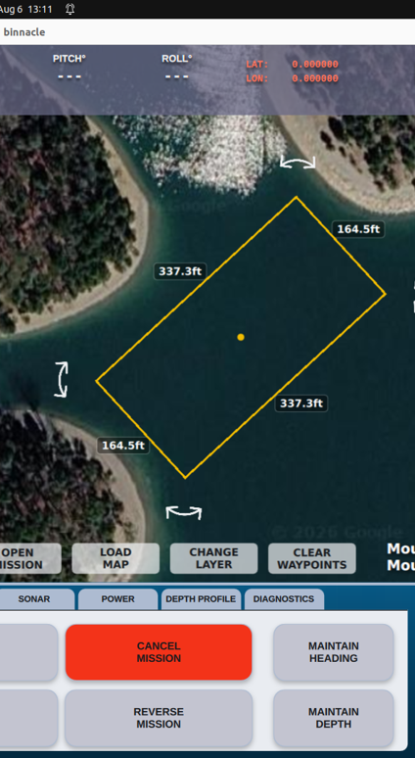
Search Pattern
When ‘Add Search Pattern’ is selected from the context menu, a box will appear in the Main Display at the cursor’s right-click position. The box will be the perimeter of the area to be filled with the desired search pattern.
Left click on the center dot of the box to edit the rotation and size of the box; the ‘Edit Search Pattern’ menu will fly out from the left edge of the display.
- Position, rotation angle, and size are editable
- Move the box by click/drag within the box or in the ‘Location’ fields of the menu
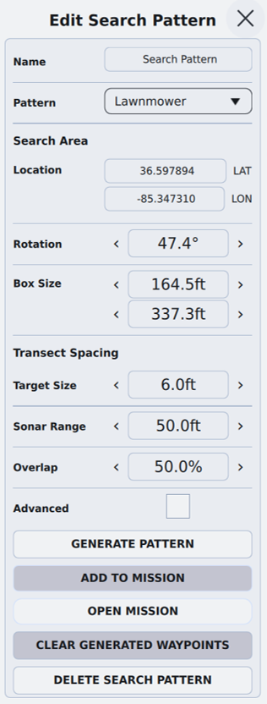
- Adjust the size of the box by a click/drag of the edges of the box or in the ‘Box Size’ fields of the menu
- Rotation of the box by a click/drag of the arrows surrounding the box or typing in the ‘Rotation’ field of the menu
  - For auto-generated waypoint transect spacing, enter target size, intended sonar range, and preferred overlap, or
  - Check ‘Advanced’ and scroll down to manually enter spacing
- Select ‘Generate Pattern’ when done, then ‘Add to Mission’
Once the box is positioned to encompass the desired search area, use the Edit Search Pattern menu to add a waypoint path. For automated results, enter the target size and sonar range intended for the mission and the software will fill the box with transect spacing based on the input provided. For operator-specific transect spacing, select the ‘Advanced Menu’ box and enter the desired values below.
Click/tap the ‘Generate Pattern’ button to create the waypoint path within the Search Pattern box. The waypoint/s can be selected to move, rotate, re-size, and edit parameters as described in the previous sections.

Mission Plan
With a waypoint/s of the desired mission selected, click/tap the ‘Open Mission’ button at the bottom of the Main Display to launch the Mission Plan fly out menu in the left edge of the display. In this menu, the operator can reorder the path using the up/down arrows or delete waypoints, which will be verified in the map.
Remember to always click/tap the ‘Load Mission’ button after any changes before beginning a mission.
Once all mission waypoint adjustments and edits have been completed, click/tap the ‘Load Mission’ button in the Mission tab of the Command Menu. The mission will now be executable by a click/tap of the ‘Begin Mission’ button.
The first waypoint of the mission is indicated by a green arrow while the last waypoint is indicated by a red arrow.
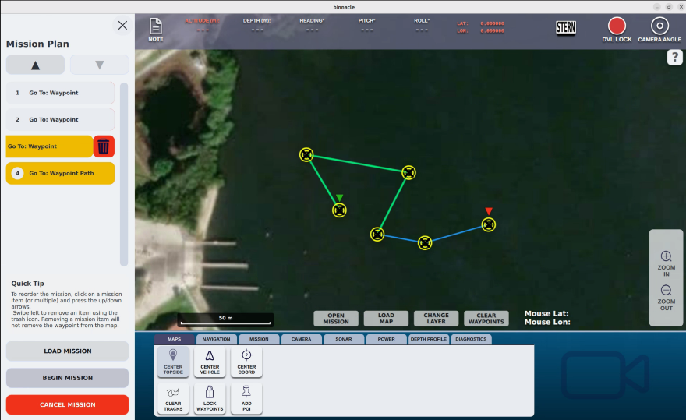

Beginning a Mission
Ensure to constantly monitor ROV navigation and behaviors during the mission and maintain constant communication between the pilot and other personnel monitoring the display, tether, and/or looking out for hazardous conditions.
Once the pilot has confirmed that the waypoint parameters are correct and ROV positioning is accurate, click/tap the ‘Begin Mission’ button in the Mission tab of the Command Menu. During a mission, the pilot can pause the ROV’s travel to a waypoint with any joystick or vertical knob input with the controller, or by clicking/tapping the ‘Pause Mission’ button.
Pausing a mission allows the pilot to manually maneuver the ROV to search, make display/operational adjustments, or assess conditions. Any time a mission is paused, a new waypoint – denoted by a white color – is created at the position the mission was paused.
To continue a paused mission, click/tap the ‘Resume Mission’ button, which will prompt the ROV to restart the mission at the new waypoint, preserving the constraints of the waypoint path/search pattern.
Upon reaching the last waypoint in the mission, the ROV will stop and hold its position until further mission commands or manual control are initiated.
To cancel a mission, click/tap the ‘Cancel Mission’ button, which ceases the mission and allows for updates in the ‘Edit Waypoint’ menu to waypoints parameters. To use modified heading, depth, or altitude, click/tap the ‘Maintain Heading’, ‘Maintain Depth’, or ‘Maintain Altitude’ buttons while a mission is canceled, which will override the waypoint parameters settings without editing them in the menu.
Ensure to ‘Add to Mission’ and ‘Load Mission’ before beginning the mission
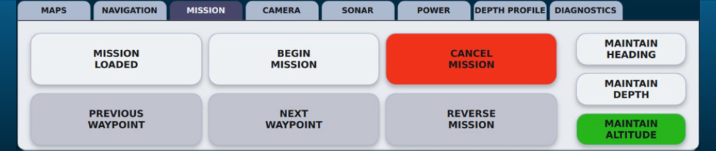

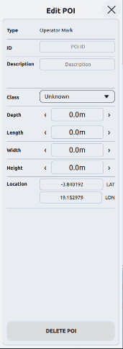
Point of Interest
While the map is in the Main Display, a Point of Interest (POI) can be created by a right-click/long-tap at the desired position and selecting ‘Add Point of Interest’. The POI will now be visible in the map. Left-click/tap the POI to select it and open the Edit POI flyout menu in the left edge of the Main Display. The menu provides entry and editing of the following attributes:
- Type, ID, & Description
- Class – Icon assignment:

  - Aircraft

  - Body

  - Gun
  - Info

  - Mine

  - Rock

  - Structure

  - Submarine

  - Triangle
- Depth
- Size – length, width, & height
- Location – lat/lon position
There is also a button to delete the POI from the map.

SHUTDOWN PROCEDURE
The following recommended shutdown procedures should be followed at the end of each operation:
- Stop recording/logging
- Disable auto controls and station keeping
- Maintain communications between the pilot and other personnel and recover the ROV using recommended procedures
- Power down the ROV with the red power mains button or shutdown of ROV subsea batteries
- Exit the Command Maritime software
- Power off control system computer and/or tablet
- Conduct a thorough post-dive inspection of the system
- If operating in salt or brackish water, soak and rinse the ROV and all subsea components with fresh water
- Allow all system components and cases to dry completely before storing

CONTROLLER MAPPING REFERENCES
Command Maritime is configured to use three different types of controllers: the built-in controllers with the Expeditionary Splashproof Controller, the VideoRay IP65 Industrial Hand Controller, or the Xbox Elite 2 Hand Controller. To switch between controllers, plug either the Industrial Hand Controller or an Xbox Elite 2 Hand Controller into a USB port of the console or tablet.
If more than one controller is connected, including the built-in tablet controllers, only one type of controller will be active at a time. The Industrial Hand Controller will override the other two controllers, and the Xbox Elite 2 Hand Controller will override the built-in tablet controllers.
Locations and mapping for the different controls on each controller are shown in the figures on the following pages.

Expeditionary Splashproof Controller
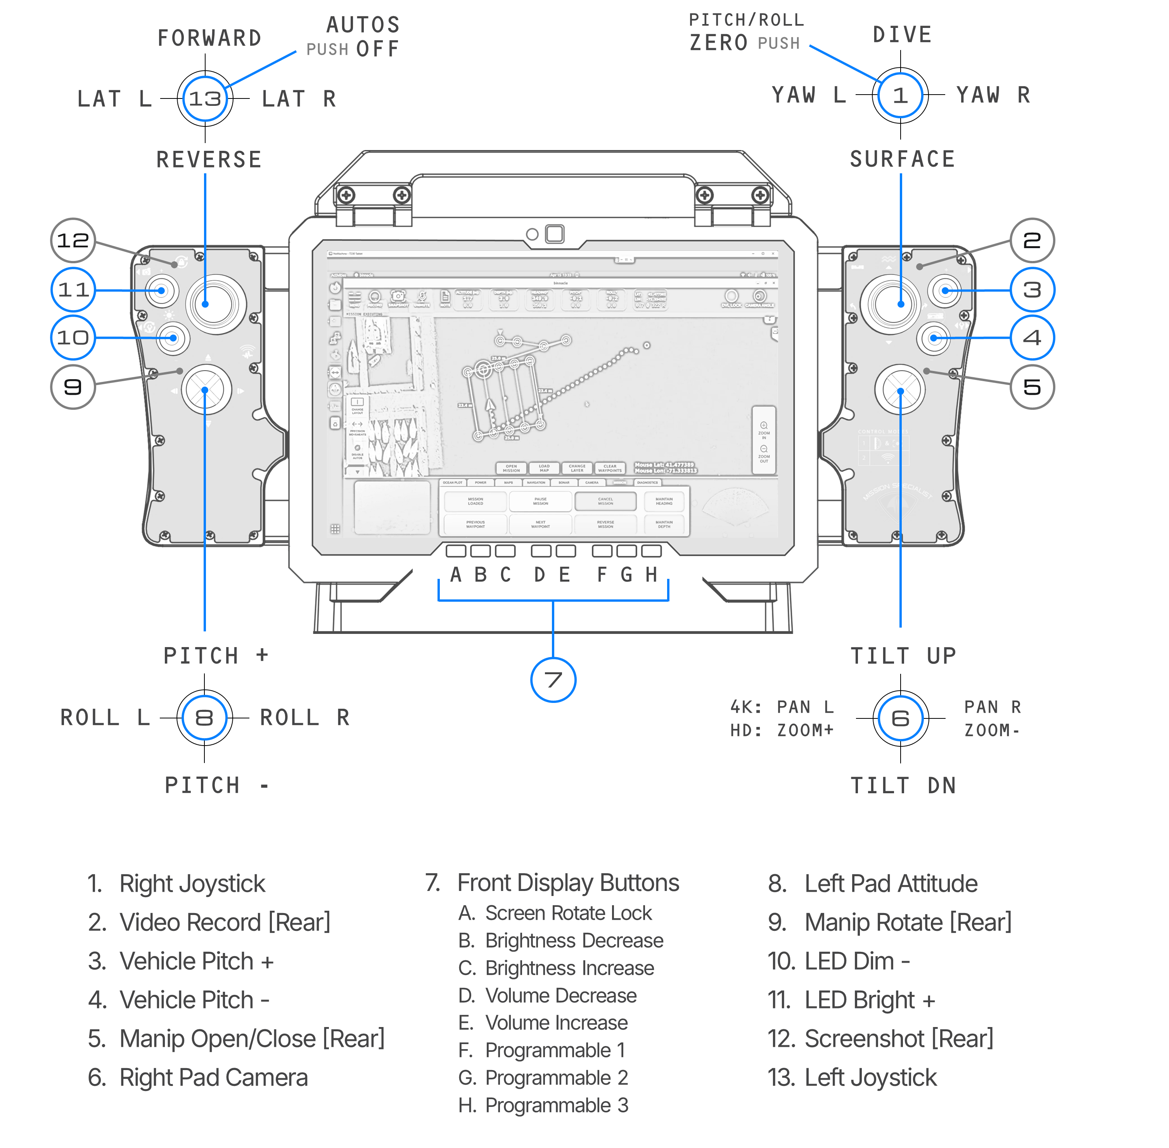

Note: All available controller functions are shown in the above diagram; dependent on ROV model and system configuration, some controls may not be functional, e.g., lateral, pitch, roll, and manipulator inputs.

VideoRay IP65 Industrial Hand Controller

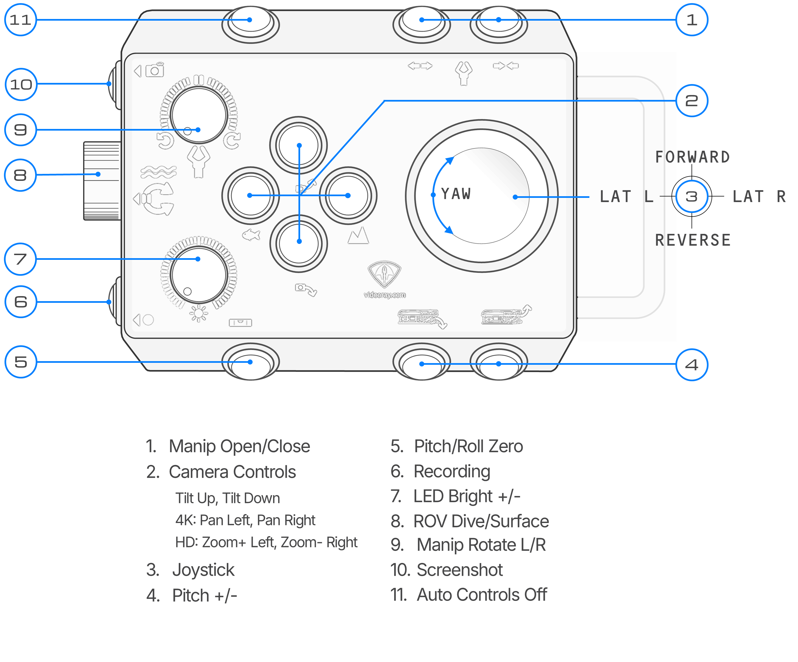

Note: All available controller functions are shown in the above diagram; dependent on ROV model and system configuration, some controls may not be functional, e.g., lateral, pitch, roll, and manipulator controls.

Xbox Elite 2 Hand Controller
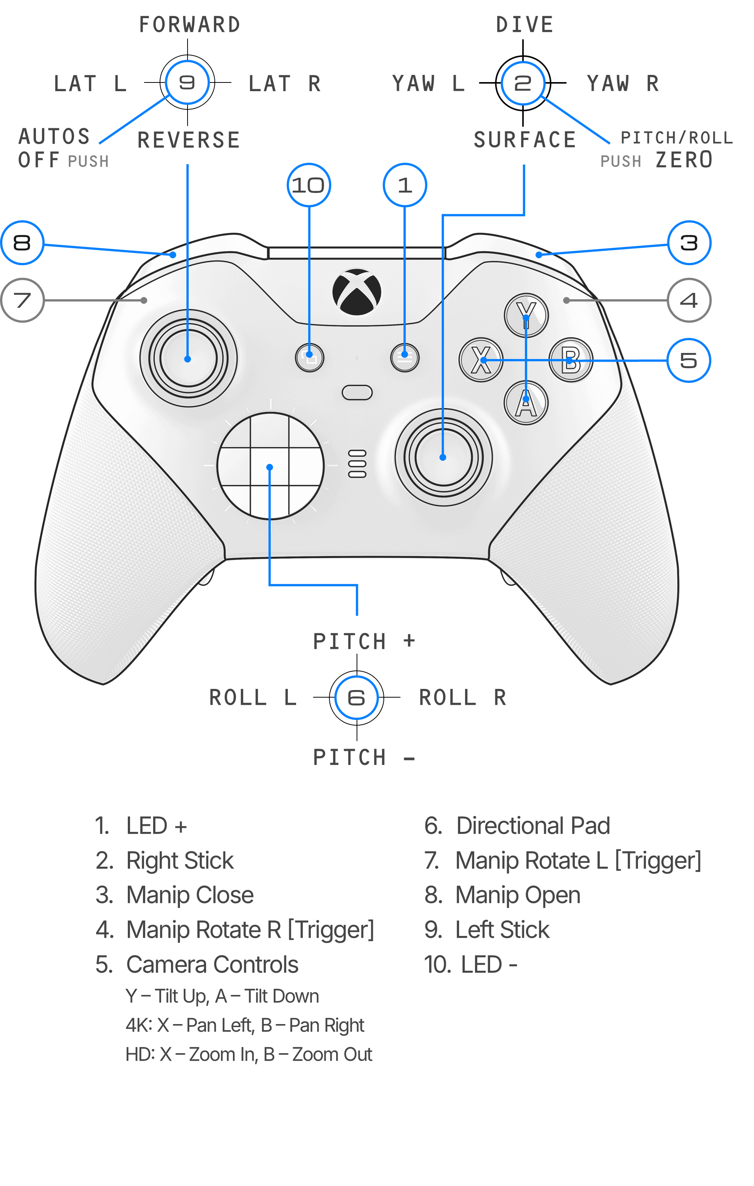
Note: All available controller functions are shown in the above diagram; dependent on ROV model and system configuration, some controls may not be functional, e.g., lateral, pitch, roll, and manipulator controls.

TOPSIDE CONSOLE REFERENCES

Workhorse Splashproof Controller Console

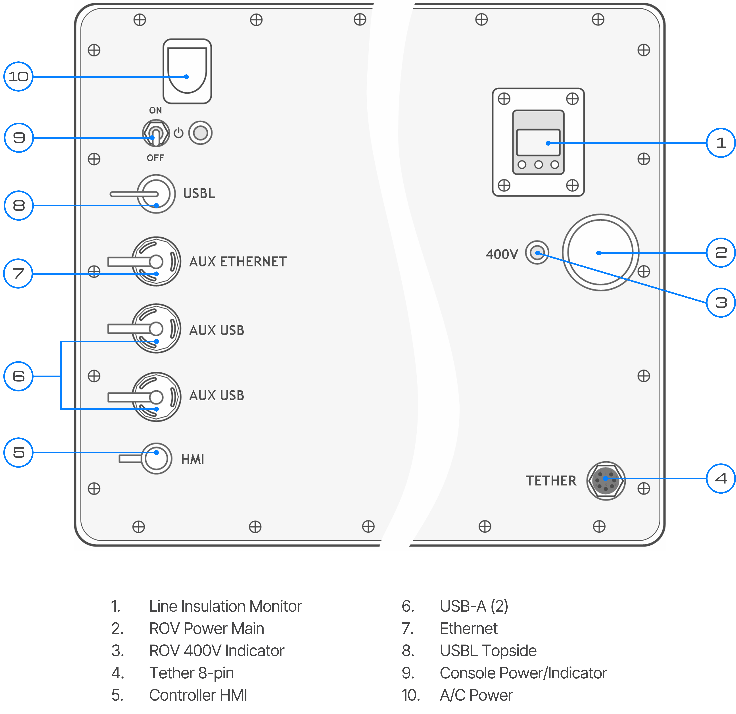

Workhorse Control Console

USING COMMAND MARITIME & GREENSEA
When VideoRay’s Command Maritime UI is launched, the software automatically reconfigures the Attitude & Heading Reference Sensor (AHRS) of the connected Mission Specialist ROV. This reconfiguration allows for proper and accurate functioning of AHRS sensors with the Command Maritime UI. However, this subsequently results in unexpected problems in Greensea UI related to AHRS functions - heading, attitude (pitch/roll), and depth. The solution is to revert the ROV’s AHRS back to its Greensea UI configuration.

One-Time Installation
Complete this section if the configuration utility is not already installed. An internet connection is required for downloading the utility and installing any missing dependencies.
- On the VideoRay controller computer, connect to Wi-Fi and open Firefox.
- Go to https://videoray.files.com and sign in using:
  - Username: quarterdeck
  - Password: VideoRay!!0
- Open the xcopy folder, select flighthack.ZIP, and click Download.
- Open the file explorer and navigate to Downloads. Locate the downloaded flighthack.ZIP file.
- Right-click flighthack.ZIP and select Extract Here. Confirm that a folder named flighthack appears and contains vr_ahrs_config_standard.sh.
- Navigate to Home (/home/videoray). If a flighthack folder already exists, rename it to an unused backup name, such as flighthack-backup, before proceeding.
- Move the newly extracted flighthack folder from Downloads into Home. Confirm that the script is located at:
/home/videoray/flighthack/vr_ahrs_config_standard.sh
- Open a terminal. Enter the following command and press Enter to make the utility files executable:
chmod +x /home/videoray/flighthack/*
- Check whether Python 3 can load NumPy:
python3 -c "import numpy; print('NumPy is available')"
- If NumPy is available appears, installation is complete. If the command reports No module named numpy, run the following commands individually, allowing each to finish:
sudo apt install python3-pip
pip3 install numpy
- Repeat the check in step 9. If installation fails or the check reports another error, contact VideoRay Support before proceeding.

Configure the ROV for Greensea
Complete this section whenever returning to Greensea after using Command Maritime. If the utility is already installed and its dependencies are available, the installation section does not need to be repeated.
- Close both Command Maritime and Greensea.
- Connect and power on the ROV. Keep both applications closed during configuration and observe the ROV’s permitted operating time out of water.
- Open a terminal and enter:
cd /home/videoray/flighthack
- Run the configuration utility:
./vr_ahrs_config_standard.sh
- Wait for the utility to finish and the terminal prompt to return. Check the output for errors. If an error appears, retain the output and contact VideoRay Support before proceeding.
- Open Greensea and verify that heading, depth, pitch, and roll readings are reasonable for the ROV’s actual position and orientation. Resolve any unexpected readings before operating.
- Close the terminal after configuration and verification are complete.

VIDEORAY SUPPORT

Self-Service Support
VideoRay’s Online Knowledge Base is a one-stop location for almost any support need. Simply enter your keyword to find detailed information about:

- Operator’s Manuals
- Standard Operating Procedures
- System Modules
- System Controls
- Specifications
- Maintenance
- Live Support
- Software Downloads

https://kb.videoray.com/

Global Support
- Email: support@videoray.com
- Phone +1 610.458.3000 (option 1)
- Remote sessions via TeamViewer are available by appointment, as well as video calls. Contact us using one of the above methods for options.

Regional Support
VideoRay Authorized Dealers and Service Centers
https://videoray.com/contact-us/locate-dealer-or-service-center/

Training
The Training team at VideoRay offers operator and maintenance courses around the globe with personalized courses and instruction.
- Email: training@videoray.com
- Phone: +1 610.458.3000 (option 2)
- Training information and opportunities: https://videoray.com/training/

Support Guidelines

Before Contacting Support
Please make sure to consider the following information before contacting VideoRay’s Technical Support to report a problem. The following information should be available:
- Name and contact information
- Name of the owner if not the same as the user
- System model
- Serial Number of the affected component(s)
- Accessories in use
- Detailed information about the issue:
  - Symptoms
  - Operating conditions that create symptoms
  - Anything new or unusual about the system or operations

Customer Care Policy
As a global company, VideoRay operates according to the highest standards of ethical conduct and behavior. These standards guide our decisions in our daily work and help us demonstrate that we take our commitments seriously.
VideoRay believes that our success is driven by our customers’ success. To achieve this mutual goal, our products must be capable, easy to learn, easy to use and reliable. To resolve problems when they arise, VideoRay Customer Care is organized into the following three groups:
- Customer Service – Resolves administrative issues
- Technical Support – Resolves technical problems remotely
- Repair – Resolves hardware problems that cannot be resolved remotely
Leveraging the latest technological advances, Customer Care relies on industry standard methods of communication as well as offering our best effort to conform to customers’ specific communications protocol requirements. When possible, VideoRay technicians can remotely access users’ systems to conduct real-time diagnosis and implement corrective actions.
VideoRay asserts that educated users make the best users and are more likely to operate their equipment in ways that optimize the use of its capabilities and maintain it properly to extend its longevity. We encourage and empower users to participate in the maintenance of their systems. Certified Training opportunities exist for customers that want to increase their operational and maintenance expertise.

Equipment Loaner
VideoRay is the most experienced and reliable vendor of observation class vehicles in the world. We achieved this by assuring the success of our customers with both an extensive and proactive support team, and back-up equipment in our loaner pool available for emergency use.
Our customers with frequent time-critical projects can add an extra level of assurance through our Comprehensive Support and Maintenance program, which allows priority access to our equipment loaner pool should a maintenance issue prevent them from using a VideoRay ROV.
Other customers may occasionally have access to rent a system if they are available. If a system is available, our support representative will advise you.

VideoRay Authorized Service Center
In addition to using its own employee resources to provide support services, VideoRay has developed the VideoRay Authorized Service Center program. Working with strategic partners around the world, together we offer time-convenient regional support and hardware repair services. VideoRay Authorized Service Centers must meet business and technical requirements to be qualified and participate in periodic update training to maintain their credentials.
VideoRay has strategically placed fully Authorized Service Centers (ASCs) throughout the world to accommodate our global clientele. Please contact us or visit our website to find an Authorized Service Center in your area.

Warranty
This warranty applies to the original purchaser only and is non-transferable. Contact VideoRay for information regarding warranty extension and warranty availability for transferred ownership.
Subject to the limitations and/or exclusions specified herein, VideoRay will repair or replace, at its expense and at its option, any system or component, which in normal use has proven to be defective in material or workmanship within two (2) years of the date of purchase.
For claims that are authorized under the provisions of this warranty during the first year of the warranty period, VideoRay will pay for the shipping of affected product(s) from the owner to VideoRay, or its authorized Dealers, and return shipment of the repaired product(s) or their replacement(s) to the owner. In order to take advantage of this, the customer must contact VideoRay for an RMA number and shipping instructions.

Warranty Limitations / Exclusions
Any separate product purchased from, but not manufactured by, VideoRay is sold with only such warranties as are made by the manufacturer thereof. VideoRay only warrants that it has title thereto, free of all liens or encumbrances.
This warranty does not apply to systems or components that are damaged or fail as a result of normal wear, such as, but not limited to, tethers, view ports, light domes and other systems or components subject to wear.
This warranty does not apply to systems or components that are damaged or fail as a result of failure of the user to read and observe instructions for proper operation and maintenance as contained in the User Instruction Manual furnished with the equipment
This warranty does not apply to systems or components that are damaged or fail by connection to improper or improperly wired sources of power, or by inadequate packing, accident in transit or elsewhere, fire, theft or another similar calamity.
VideoRay will not be responsible for any asserted defect which has resulted from Acts of God, normal wear, misuse, abuse, improper configuration, repair, or alteration made, or specifically authorized by, anyone other than an authorized representative of VideoRay. The giving of, or failure to give, any advice or recommendation by VideoRay shall not constitute any warranty by or impose any liability on VideoRay.
The foregoing constitutes the sole and exclusive remedy of the purchaser and the exclusive liability of VideoRay and is in lieu of any and all other warranties, express, implied or statutory as to merchantability, fitness for purpose sold, description, quality productiveness, or any other matter. Under no circumstances shall VideoRay be liable for special, incidental or consequential damages, or for delay in performance of this warranty.
For more information or to submit a warranty claim, contact VideoRay.

COPYRIGHT NOTICE
This material is copyright protected. No material may be reproduced or transmitted in any form or by any means for any purpose without the expressed written consent of VideoRay.
This document is deemed accurate at the time of its writing; however, it is not a legal contract and the information contained herein should not be construed to represent any form of commitment. This document as well as the associated products and services are subject to change without notice.
Copyright © 2026, VideoRay, an AV Company.

